Lab 2 Report
Group: 22
Student Name: Lei Jiang, Student ID: 110195911
Student Name: Kun Lan, Student ID: 110194584
Date: May 13, 2026

1a. IP Address of www.example.net
I ran the command $ dig www.example.net to find its IP address. The Answer section of the dig result shows that www.example.net has two IP addresses: 172.66.175.59 and 104.20.21.8. (See the terminal screenshot of the dig command output for evidence.)
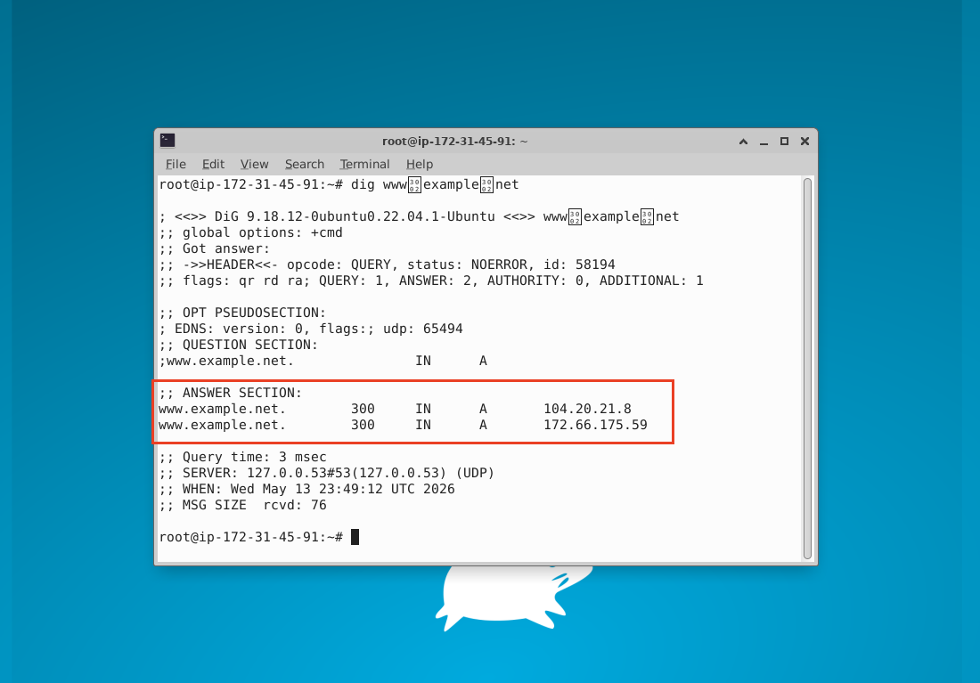

1b. Analysis of the DNS Request Packet in Wireshark
After clearing the DNS cache with $ sudo resolvectl flush-caches, I started Wireshark on interface ens5 and ran $ dig www.example.net. I then stopped the capture and applied the dns filter.
The DNS request packet (No. 685) is the one sent from my VM.
- Source: 172.31.45.91 (my VM IP)
- Destination: 172.31.0.2
- Info: “Standard query 0x555a A www.example.net OPT”
In the Packet Details pane, the protocol stack clearly shows: User Datagram Protocol ← This confirms that the transport layer protocol is UDP.
Expanding the User Datagram Protocol section, the UDP header fields are:
- Source Port: 55835
- Destination Port: 53
- Length: 52
- Checksum: 0x85e1
(See the detailed Wireshark screenshot of the expanded UDP header in the DNS request packet for evidence.)
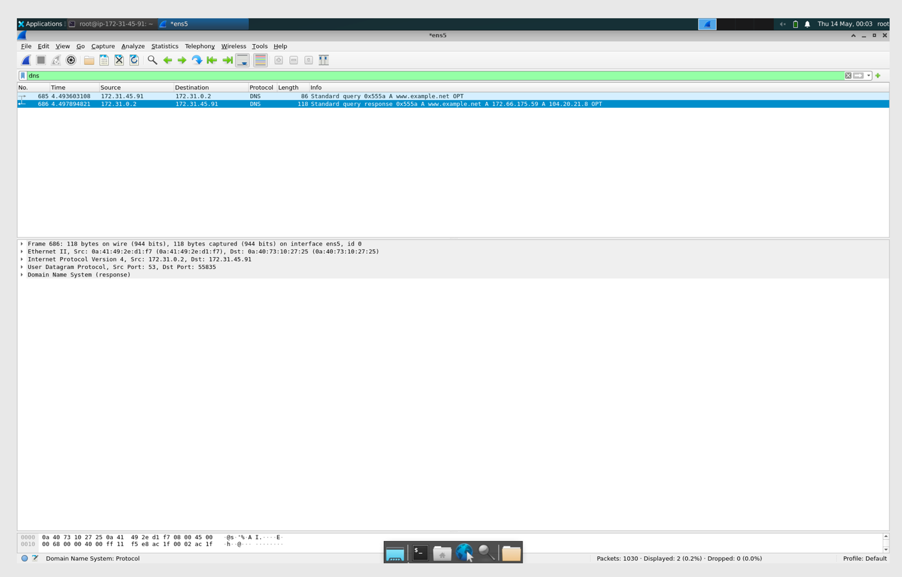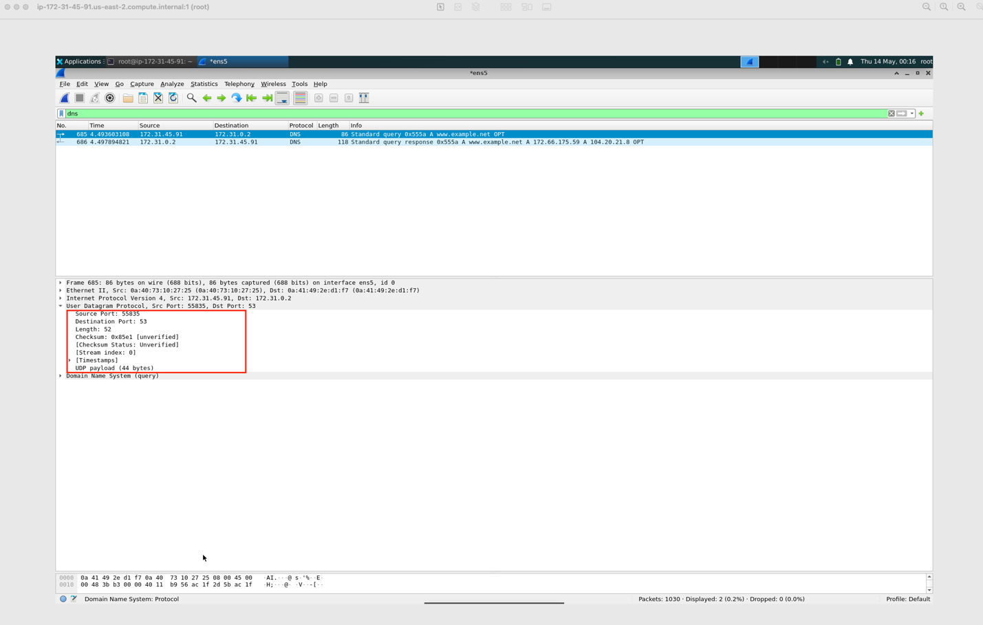
1c. Destination IP Address in the DNS Request Packet and Proof of No Connection Setup
In the DNS request packet (step 1b, packet No. 685), the Destination IP is 172.31.0.2. This is the IP address of my local DNS server.
To confirm there is no connection setup before the DNS request (as required by the lab), I examined the full packet list window in Wireshark (without the dns filter). As shown in the screenshot, no packets were exchanged between my VM (172.31.45.91) and the local DNS server (172.31.0.2) prior to the DNS request packet.
This proves that DNS is serviced by UDP and has no connection setup (no handshake) before sending the DNS request packet. (See the full Wireshark packet list screenshot for evidence.)
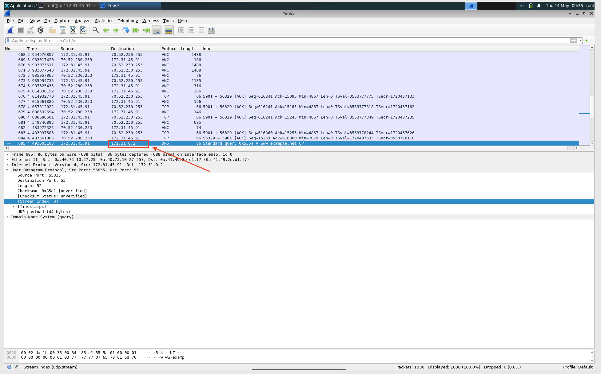
2. TCP Connection Setup and Reliability Verification
I started a fresh Wireshark capture on interface ens5. After clearing the browser history and DNS cache, I accessed www.example.net using Firefox and then stopped the capture.
I applied the display filter ip.addr == 172.66.175.59 or ip.addr == 104.20.21.8.
Before the HTTP request, there are exactly three packets forming the TCP 3-way handshake (packets 1208, 1210 and 1211):
- SYN packet (No. 1208)
- SYN-ACK packet (No. 1210)
- ACK packet (No. 1211)
This confirms the connection setup stage between my VM and www.example.net.
I checked one of these packets in the Packet Details pane and confirmed that the transport layer protocol is TCP (Transmission Control Protocol).
During the message exchange, I located an ACK packet (for example, packet No. 1211) with the flags bit A=1. This provides evidence that TCP is a reliable protocol because it sends acknowledgments to confirm the receipt of packets (unlike UDP).
I verified the selected ACK packet: it does not contain application data (no TCP payload is present, Len=0). This shows that an ACK packet might or might not contain application data.
(See the Wireshark packet list screenshot and the detailed ACK packet screenshot for evidence.)
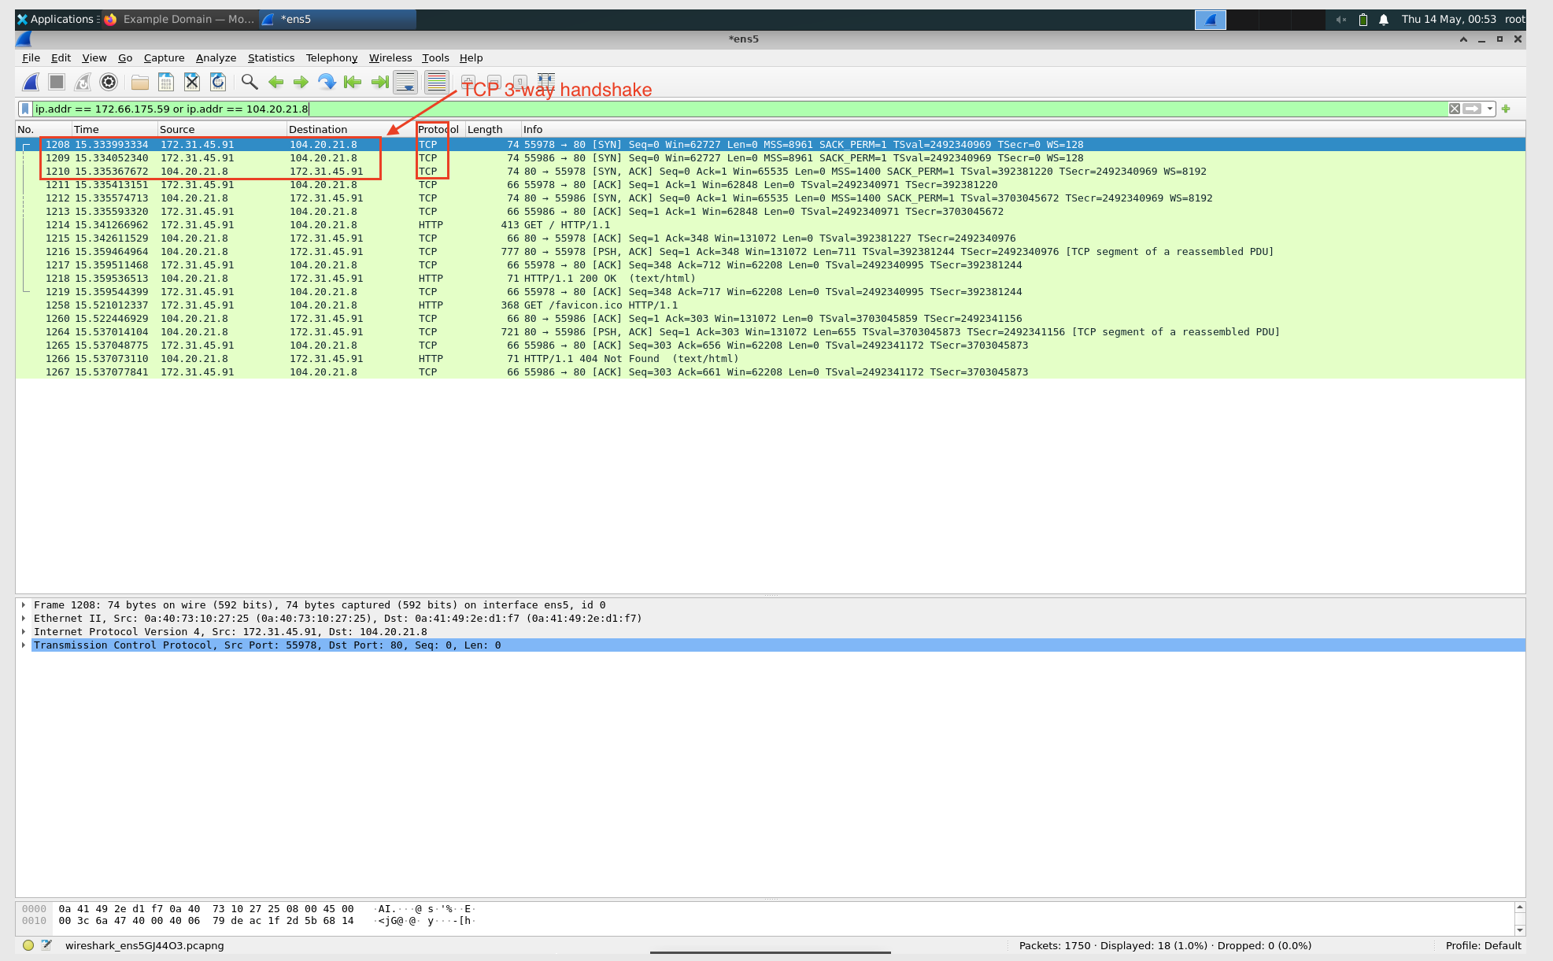
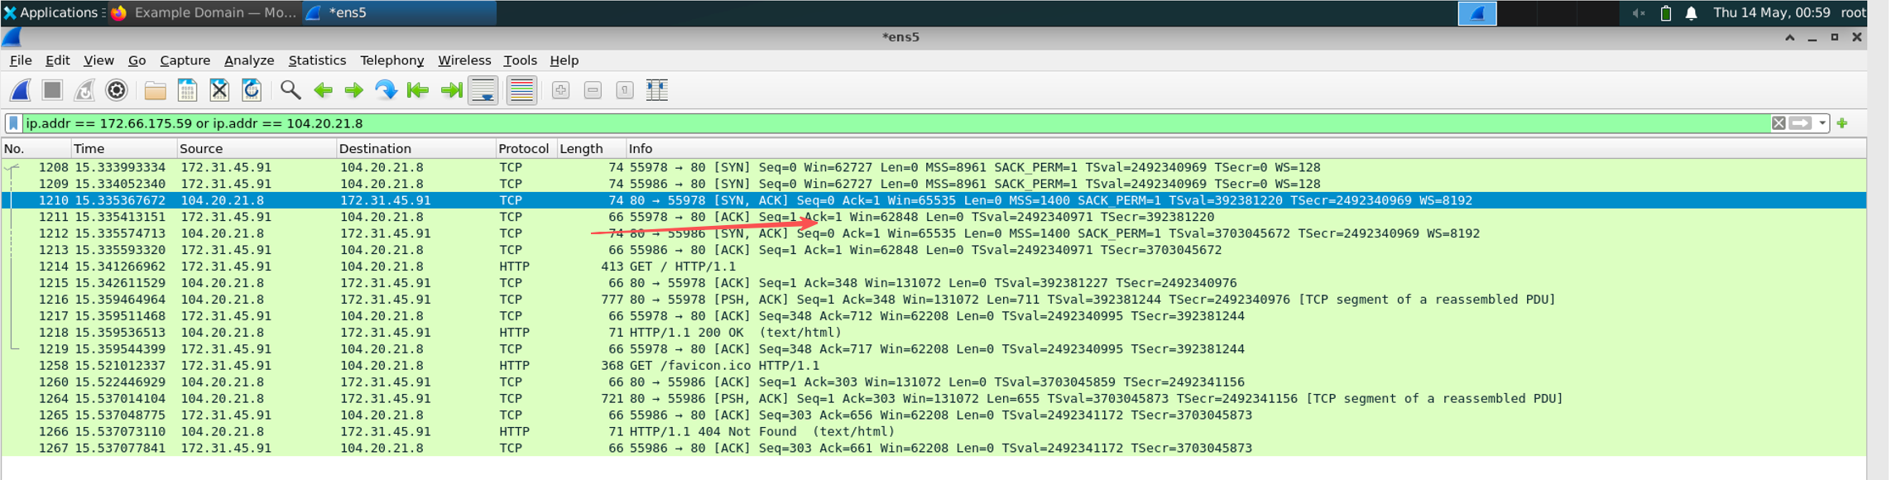
3. Detailed TCP Header Analysis
I used the same Wireshark capture (filtered by ip.addr == 172.66.175.59 or ip.addr == 104.20.21.8) after accessing www.example.net with Firefox and closing the webpage.
a. The first packet from my VM to www.example.net is packet No. 1208, which is the SYN packet (the first packet of the 3-way handshake).
- Source Port: 55978
- Destination Port: 80
- Source IP: 172.31.45.91
- Destination IP: 104.20.21.8 (one of the IPs of www.example.net) These values are confirmed in the TCP header and IP header respectively. (See the detailed Wireshark screenshot of packet 1208 for evidence.)
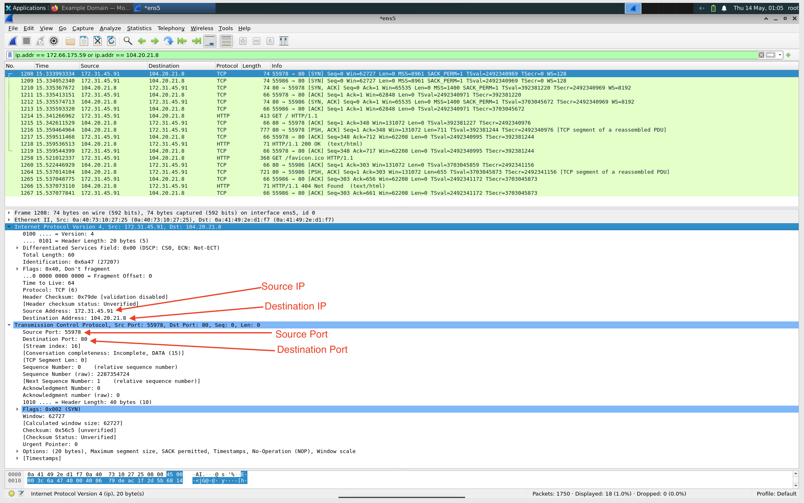
b. In the SYN packet (No. 1208), the sequence number is 2287354724. It is a random number, as expected for the initial sequence number in TCP. (See the screenshot highlighting the sequence number.)
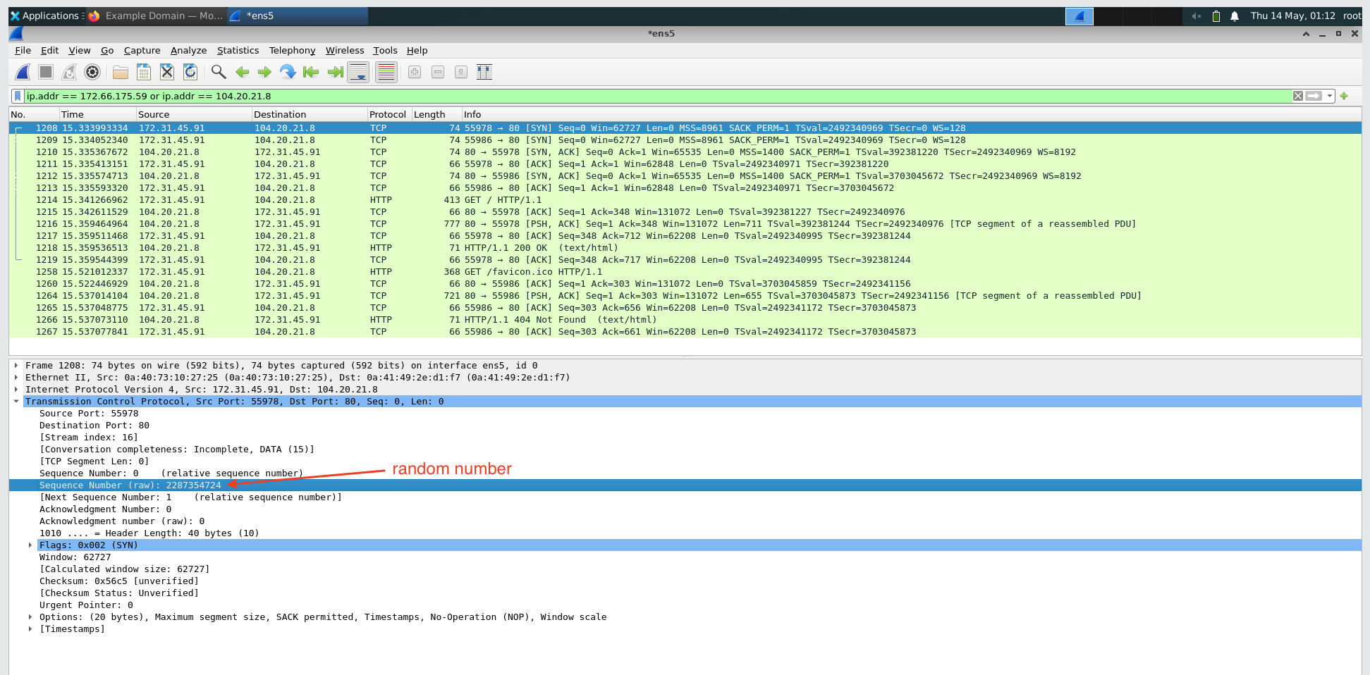
c. In the SYN-ACK packet (No. 1210), the TCP header flag bits U|A|P|R|S|F are: U=0 | A=1 | P=0 | R=0 | S=1 | F=0. (See the screenshot of the SYN-ACK packet flags.)
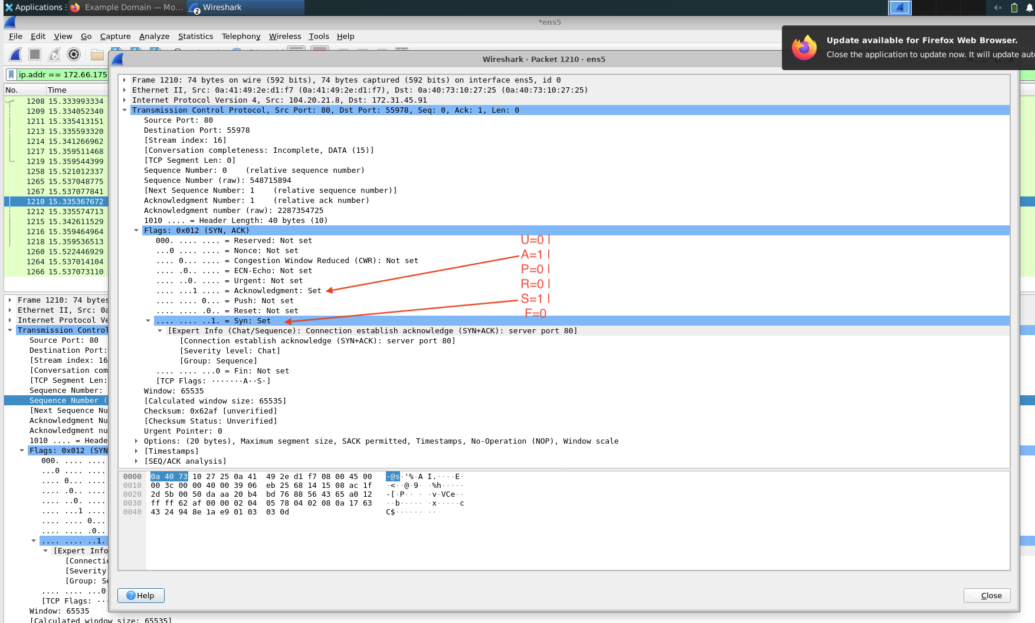
d. The receive window size in the SYN-ACK packet (No. 1209) is 62727. The receive window size in the HTTP response packet (e.g., No. 1218) is 16. They are not equal.The receive window tells the partner the current receive-buffer size. (See the two screenshots comparing window sizes.)
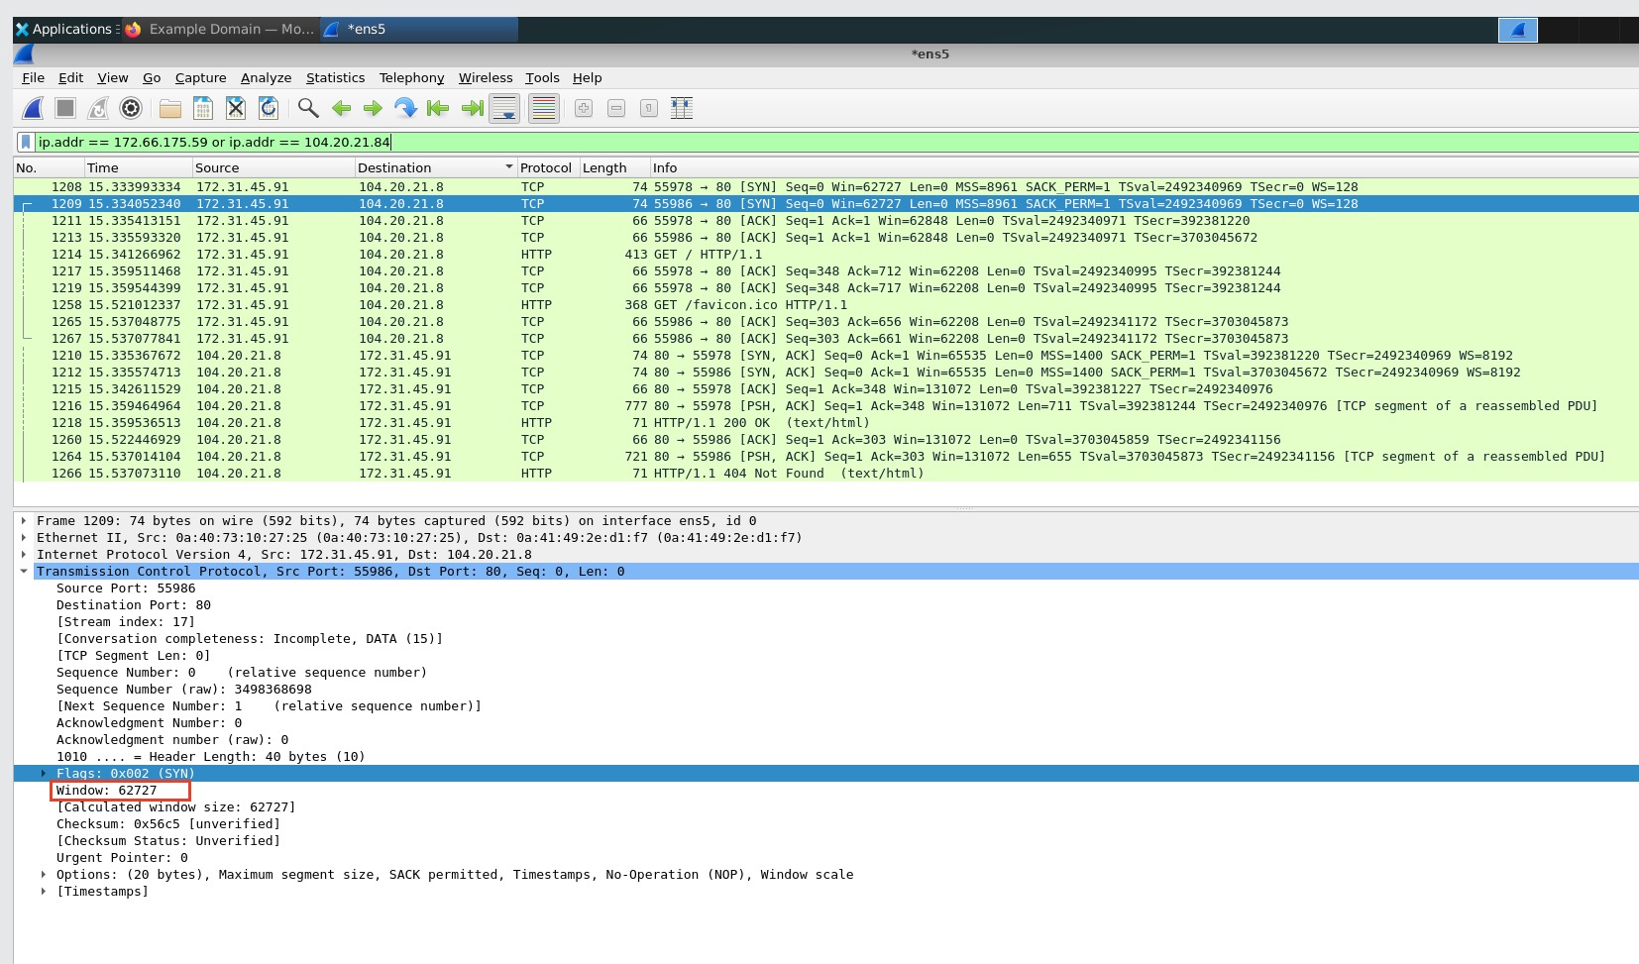
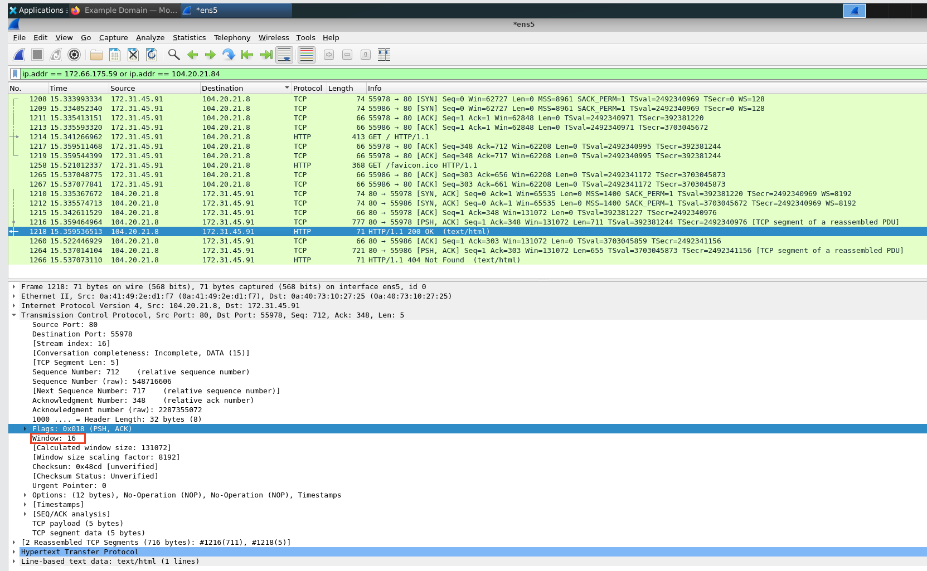
e. In the HTTP request packet (packet No. 1214), the sequence number is 1 and the payload size (Segment Len) is 347. The next sequence number is calculated as 1 + 347 = 348. This value matches exactly the sequence number of the next packet sent by my VM (packet No. 1219, Seq=348). (See the screenshot of packet 1214 and packet 1219 for evidence.)

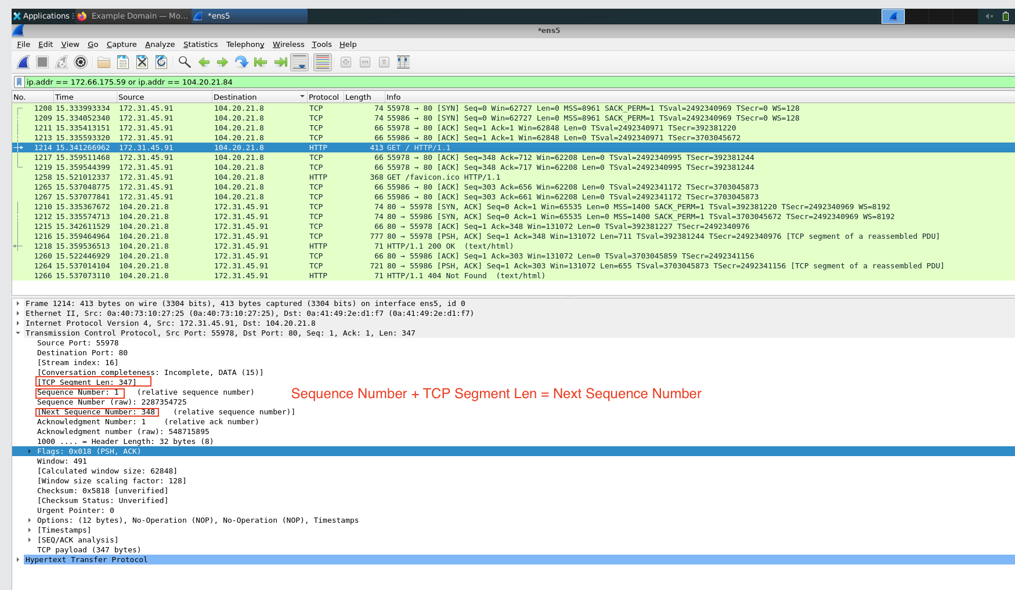
f. In the HTTP response packet (packet No. 1218), the acknowledgement number is 348. Yes, it is exactly the same as the next sequence number calculated in part e (1 + 347 = 348). This is because TCP is a reliable protocol — the acknowledgement number tells the sender that the receiver has successfully received all bytes up to the next expected sequence number.
(See the detailed Wireshark screenshot of packet 1218 for evidence.)
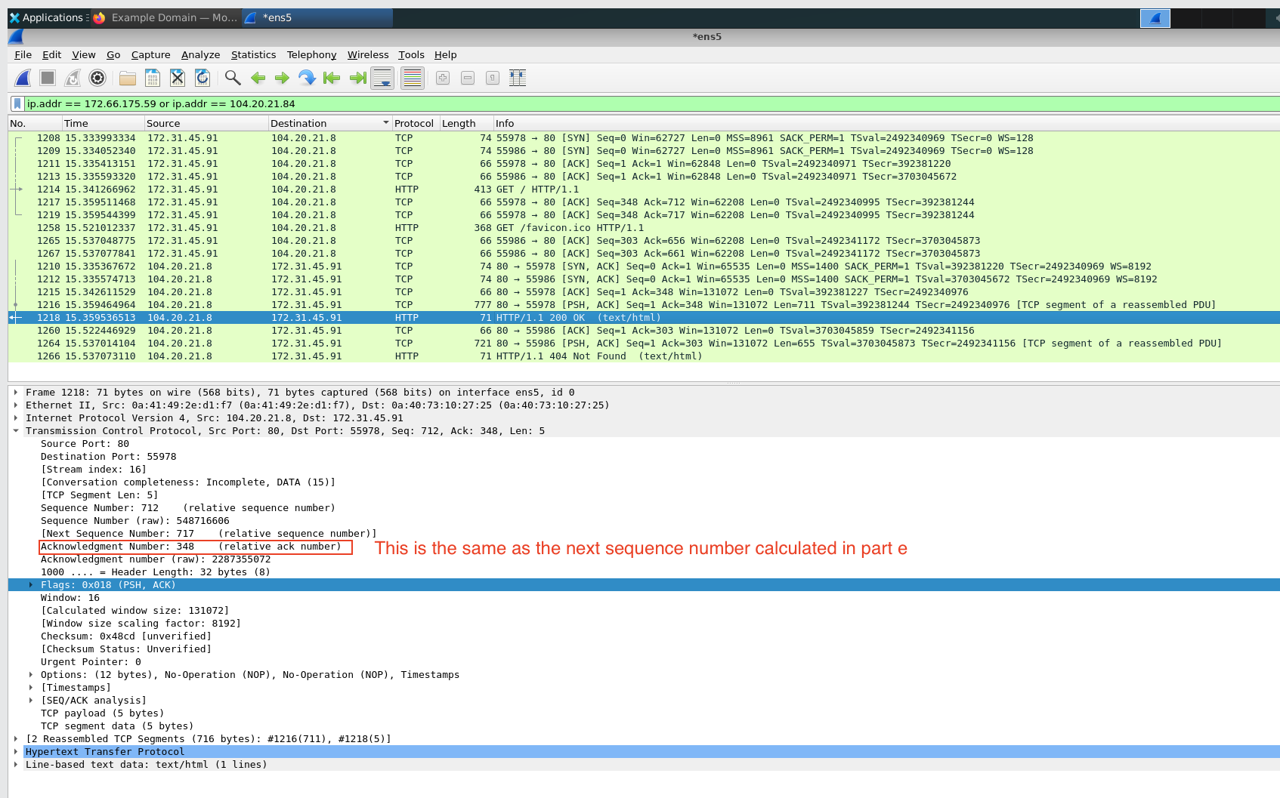
g. In the HTTP response packet (packet No. 1218), the TCP header flag bits U|A|P|R|S|F are: U=0 | A=1 | P=1 | R=0 | S=0 | F=0.
(See the detailed Wireshark screenshot of packet 1218 Flags for evidence.)
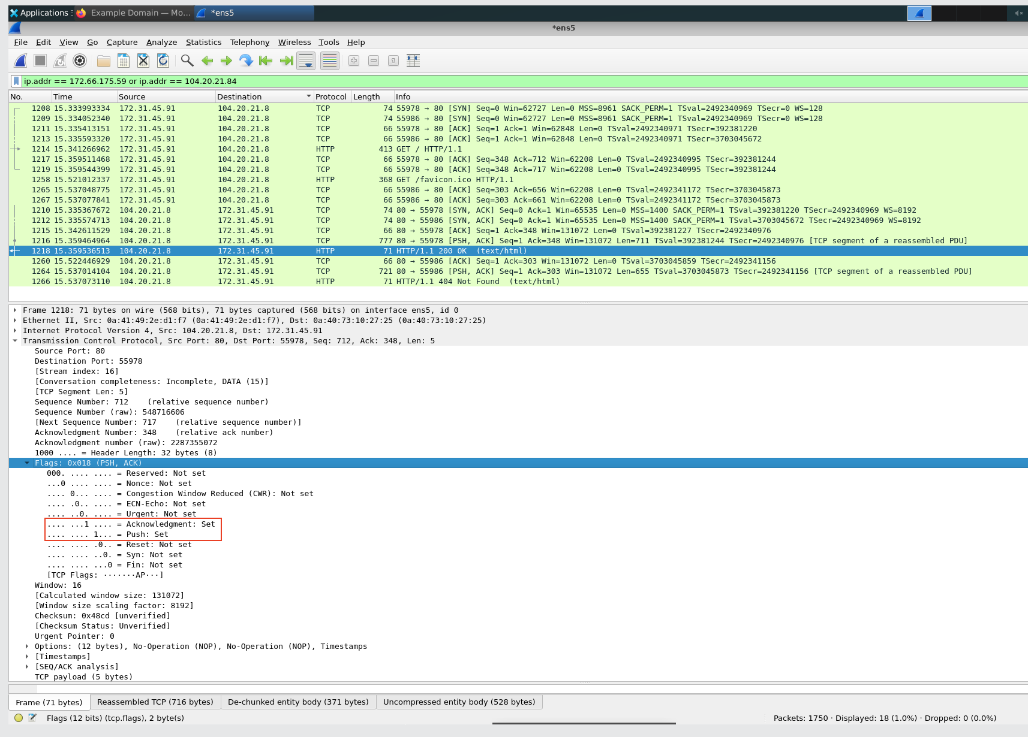
h. The packet my VM requests to terminate the TCP connection (after I closed the webpage) is packet No. 461. This packet has the flags bit U|A|P|R|S|F as: U=0 | A=1 | P=0 | R=0 | S=0 | F=1.
(See the detailed Wireshark screenshot of packet 461 for evidence.)
